**HOPE ARTIFICIAL INTELLIGENCE**

***CONFUSION MATRIX & CLASSIFICATION REPORT MANUAL CALCULATION FOR DIFFERENT ALGORITHMS***

1. SVM Classification Handson

CM

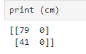

CLF REPORT

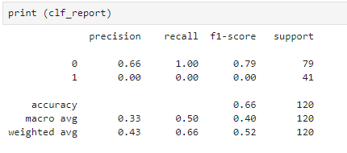

**Manual Calculation:**

**Accuracy = T (Clicked) + T (Not Clicked)**

**T (Clicked) + T (Not Clicked)+F(Clicked)+F(Not Clicked)**

**= 41 + 0**

**79+0+41+0**

**= 41**

**120**

= **0.66**

**Recall = T (Clicked)**

**Total input(clicked) in the test set**

**= 41**